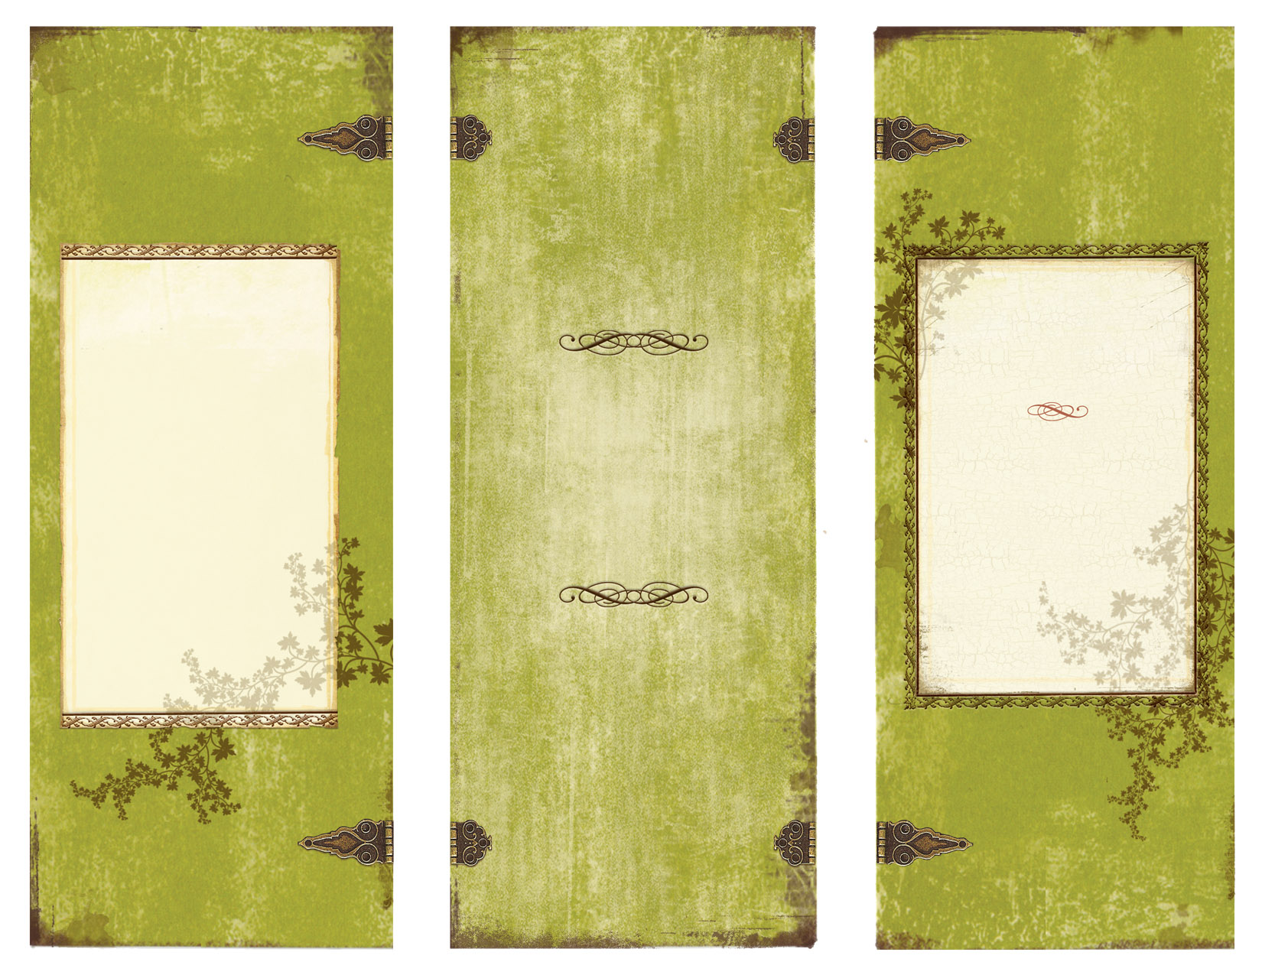

Jsanchez1@sharylandisd.org

Where the fusion

of scholarly ambiance

and cuisine meet!

Bon Apetit!

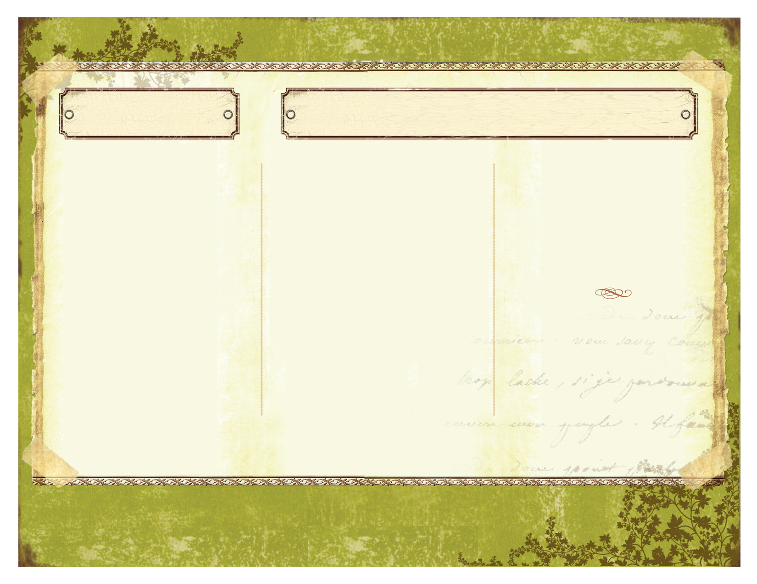

All appetizers are expected to be a half page minimum and two page maximum.

Enjoy these activities.

Learn and have fun.

Show off what you have learned.

Make learning YUMMY!

D’ Sanchez

Cafe

**English II**

**Pre-Advanced Placement**

Room 114

Sharyland High School

Entrées

Some entrees are enough to feed more than one. Be sure to check on the portions. Prices vary. Entrees can only be ordered once.

**Crab Puffs**- take a first person perspective and write a letter to a particular person expressing, informing, persuading, etc. a situation. Use details from the novel to support your purpose.

**Cheese & Fruit Tray-** in 15 lines or more, write a free verse or rhymed poem that reflects the response of the question. Utilize DIDLS in your writing.

**Potato Skins:** Write a body paragraph that incorporates embedded quotes and commentary. Create an in-depth analysis.

**Mozzarella Sticks-** create a visual on 8X10 paper that embodies the theme or answer to the question; visuals must be original via sketching, collages, painting, etc. Color should be applied to reflect tone. Include caption.

**Fried Calamari-** Parenthetically cite 5 pieces of meaningful textual evidence. Provide analysis on what each piece reveals.

**Beef Sliders-** write how you relate to the character. Use textual evidence to compare with your own personal experience.

**Personal Pizza**- re-write the story from another character’s perspective. This could be a form of personification where an object is speaking.

Appetizers

All starters could only be ordered once per piece of literature.

**Botana**:-Body Biography- character analysis- sketching, symbolism, poetry, textual evidence.- A **Shrimp Scampi**- Literature Scrapbook- in depth analysis of characters, setting, plot, via mementos, textual evidence, symbols- B **New Style Sashimi** - Newspaper- practice editorial and advertising skills- informative writing B **Mac&Cheese Carbonara**: Movie project- produce and direct mini film for viewing that reflects literature piece. A **Creole Etouffe-** CD Project- compile a list of 5 songs that thematically relate to the piece of literature. Design a cover for the CD and analyze correlation of lyrics to book on inside of cover. B **BLT-** Book Cover- Design a cover of the book that is original and reflects the characters, conflict, and/or theme of the novel. Include a synopsis on the back with a letter from the author**. C Deli-Deluxe Croissant**- Diorama**-** recreate a scene from the novel with items, sculptures, and a caption.C **Spaghetti & Meatballs**- Speech- write a speech from the perspective of the protagonist in which he/she informs or persuades using textual evidence. B **Chicken-Fried Steak**: Children’s Book- place the text in a kid-friendly book. Visuals and text should be appealing. A **MooGooGaiPan-** Movie Poster / Trailer- should include ethos, pathos, logos, visuals, lines from novel..A/B **Mission Roll-** MySpace/Facebook homepage B **New York Pizza**- Narrative- rewrite the last chapter of the novel- write the first chapter of the following book (to be continued) B **Veal Parmesean**- Visual Journey of character C

All entrees will come with a detailed handout that clarifies activity and objectives. Rubrics will be included.