

**Select**

**“create account”**

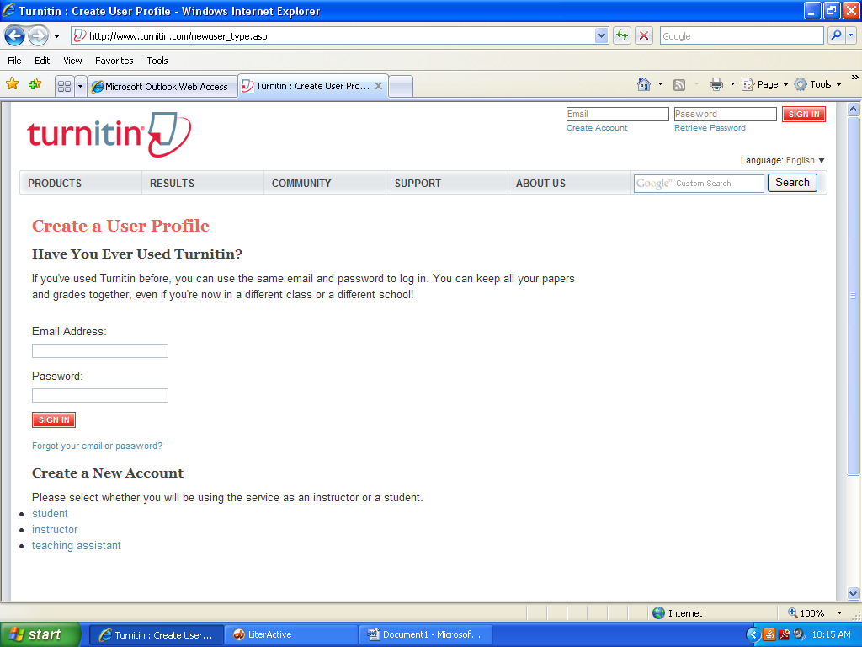

**Select “student”**

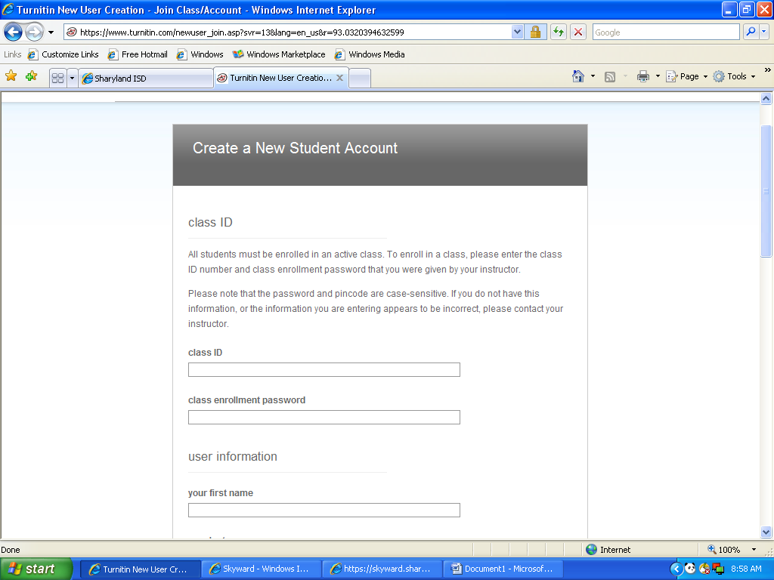

**Enter class id:___________________**

**and password:**

**and your information. . .**

*you can use your @students.sharylandisd.org account; <http://www.sharylandisd.org/domain/1096>

be sure to select **“agree”**

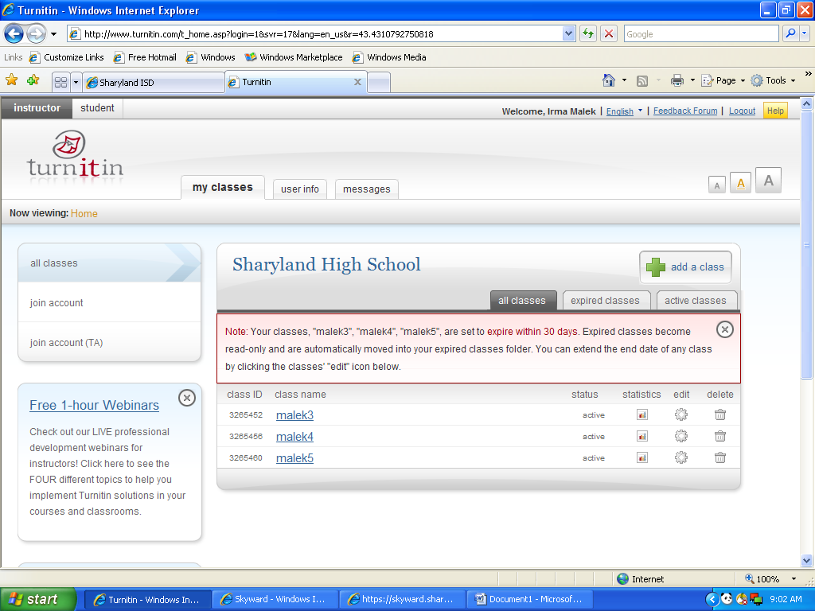

**Find and select**

**your class**

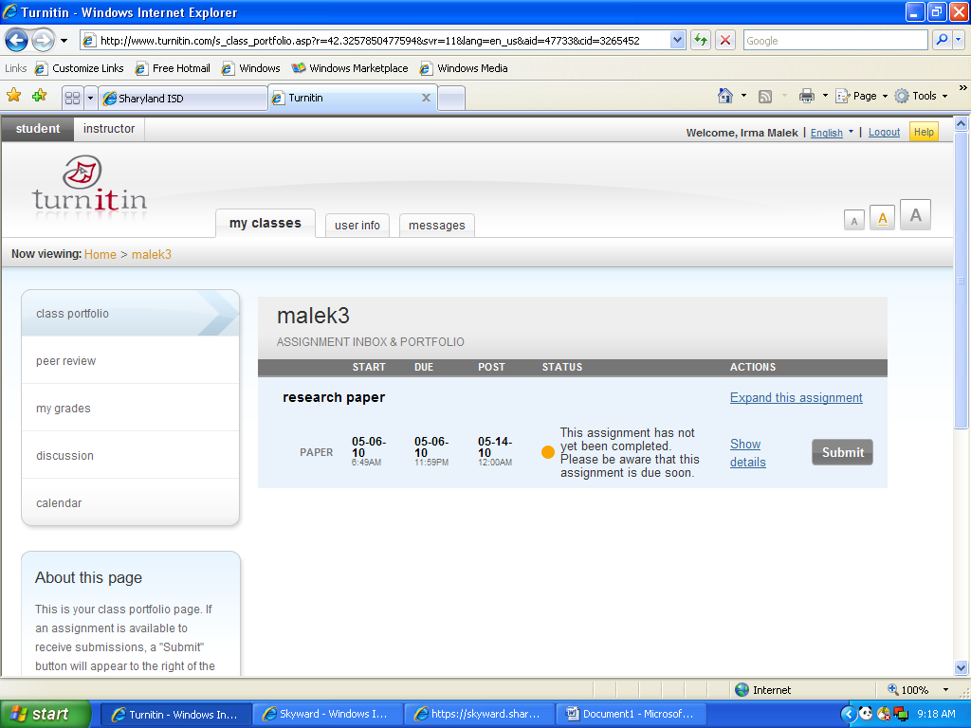

**find and verify the assignment name and date; select “submit”**

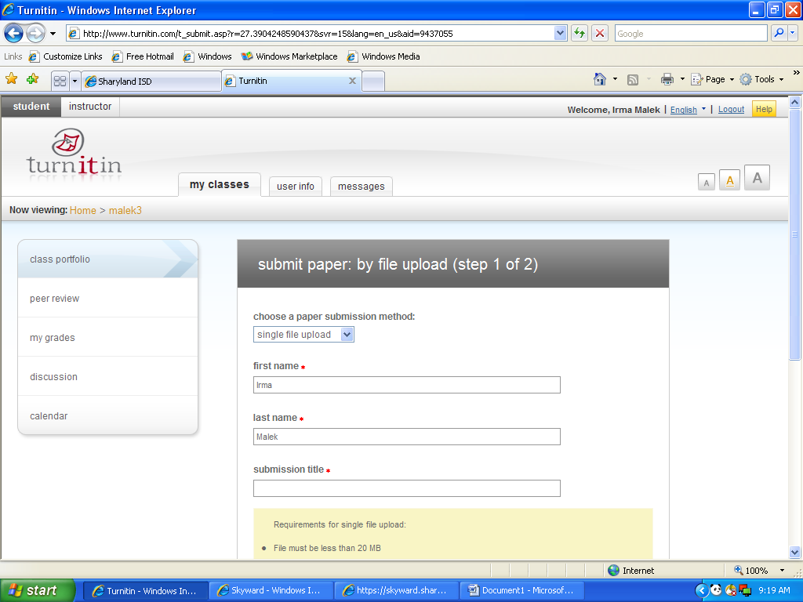

**Fill out your information and the title of the assignment.**

**Notice the acceptable formats that can be submitted.**

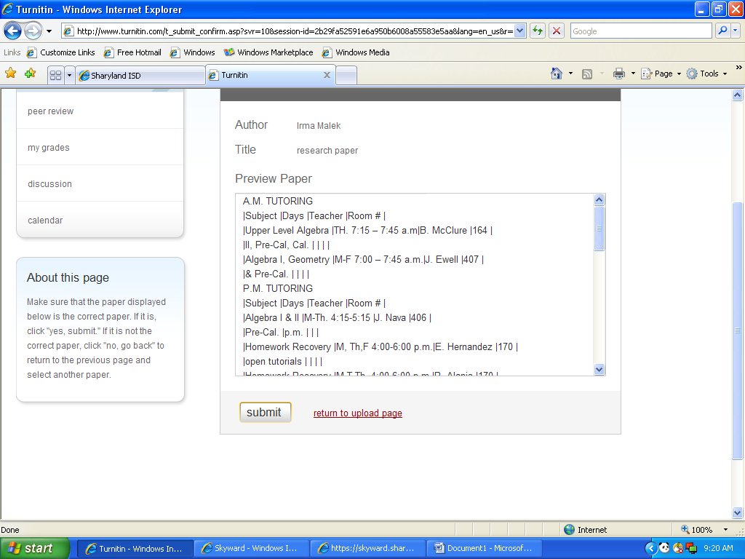

**Verify that you are submitting the correct paper. Then select “submit”.**